

College of Engineering

Assessment Plan
Program Level Learning Outcomes
August-December 2010 – January-June 2011

1. Learning Outcomes.

The Student Learning Outcomes for an academic program are comprised by two main blocks: Institutional Learning Outcomes and Program Learning Outcomes. The Institutional Learning Outcomes are defined and reviewed by the Academy of Institutional Learning Outcomes. The Program Level Learning Outcomes are defined and reviewed by the Academies.

The Institutional Learning Outcomes are four and focus on: Verbal and Written Communication Skills, Critical Thinking, Continuous Learning/Information Literacy and Tolerance to Diversity.

The Program Level Learning Outcomes, for the programs offered by the College of Engineering are divided into two blocks: learning outcomes common to all engineering programs (with a strong emphasis on basic sciences and problem solving) and learning outcomes specific to the academic program (with a strong emphasis on the primary and complementary areas of knowledge of the program.

The Program Level Learning Outcomes that apply to all engineering programs, defined in the previous program review process (included in Evidence #35 of the Capacity Report for the WASC Initial Accreditation), were five and were identified as follows:

The student of a CETYS University Bachelor’s in Engineering Program will…
- SLO_ENG1: …correctly apply to engineering, the tools provided by the basic sciences, such as physics, calculus, probability, statistics and programming to the solution of diverse problems.
- SLO_ENG2: …design analytic and functional models, quantitatively and qualitatively, for the analysis and improvement of systems for diverse applications.
- SLO_ENG3: … effectively use software tools and technologies to build solutions to engineering problems.
- SLO_ENG4: … effectively design and manage projects.
- SLO_ENG5: … (Clear and effective communication in English) … be able to express his ideas clearly and with an appropriate language, in a verbal, written, and visual way in English.

The review of these learning outcomes took into consideration the following three general guidelines:

- Since these learning outcomes apply to all engineering programs, all Academies should participate in the review process.
- As a part of the WASC process, recommendations were made with regards to the amount of learning outcomes with regards to assessment implications, thus integration of learning outcomes to reduce the amount is desirable.
- The learning outcome that has to do with “Clear and effective communication in English” must be included.

The Academies analyzed the five original learning outcomes and re-defined them into the following three Program Level Learning Outcomes that apply to all engineering programs:

The student of a CETYS University Bachelor’s in Engineering Program will…
- SLO_ENG1: …solve problems relating to the improvement of diverse systems, correctly applying the knowledge and tools provided by the basic sciences and/or software technologies.
- SLO_ENG2: … effectively design and manage projects.
- SLO_ENG3: … (Clear and effective communication in English) … be able to express his ideas clearly and with an appropriate language, in a verbal, written, and visual way in English.

This re-definition allows for a more clear identification of the learning outcomes expected for all engineering programs, and also allows for the design of a more manageable program level assessment process and plan (which will be explained in further sections of this document).

Also as a part of the previous program review process, Program Level Learning Outcomes that apply to specific engineering programs were defined (also included in Evidence #35 of the Capacity Report for the WASC Initial Accreditation). Each Academy analyzed the original program level learning outcomes and re-defined them if necessary. This re-definition also allows for a more clear identification of the learning outcomes expected for the academic program, and updates them, taking into account assessment considerations. The analysis and re-definition of these Program Level Learning Outcomes may be found in the corresponding Program Review documents for each program.

2. Curricular Mapping.

The curricular mapping for the program level learning outcomes, in their redefined versions according to section 1 of this document, considers the following levels:

- INTRODUCTORY (I): "At the end of the course, the students know, understand, comprehend and are familiar with the course topics". It is expected that students have little or no knowledge of the course topics previous to the course. Knowledhe and abbilities acquired from previous corses may be used to develop students in the solution of problems of low to mid level complexity. New topics are introduced with a basic application level, sufficient enough for the student to comprehend implications for further applications. It is expected for the student to relate previous concepts and integrate them to his or her new base of knowledge, identifying applications via the identification and solutions of problems and cases at a basic level.

- REINFORCEMENT (R): "At the end of the course the students are able to analyze and apply course topics in various contexts, which present diverse levls of dificulty". Knowledge, skills and abilities acquired from previous courses are used to develop solutions to application problems, of mid to high level complexity, relating to the area of knowledge of the profession. It is expected that the student develop a higher level of analysis skills and learn to use in a more efficient manner the tools and methodologies relating to the area of knowledge of the profession.

- EVALUATION - (E): "At the end of the course, the students exhibit an integrated understanding of the course topics and their application, knowing when and how to apply them". Knowledge, skills and abilities acquired throughout previous courses are used to identify and solve problems, where the student is expected to design, integrate and evaluate tools and methodologies relating to the area of knowledge of the profession.

It is important to note that the curricular mapping of the Institutional Level Learning Outcomes for all academic programs, uses a three level scale that is congruent with the above levels, using different nomenclature (Sufficient, Improvable, Outstanding). This scale is also congruent with the program level scale of Introductory, in Development and Developed used by some of the Academies.

The three program level learning outcomes that apply to all engineering programs are mapped throughout the courses for each program, according to the following tables:
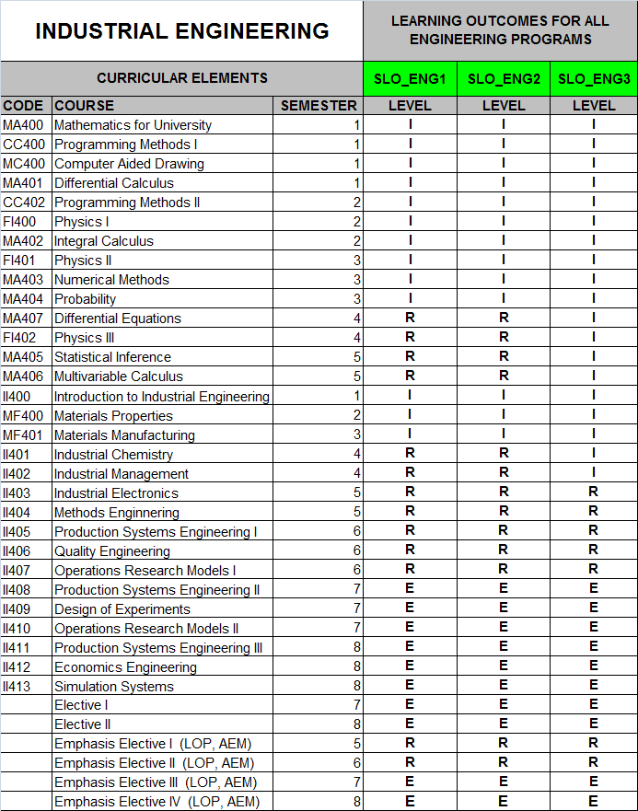 | 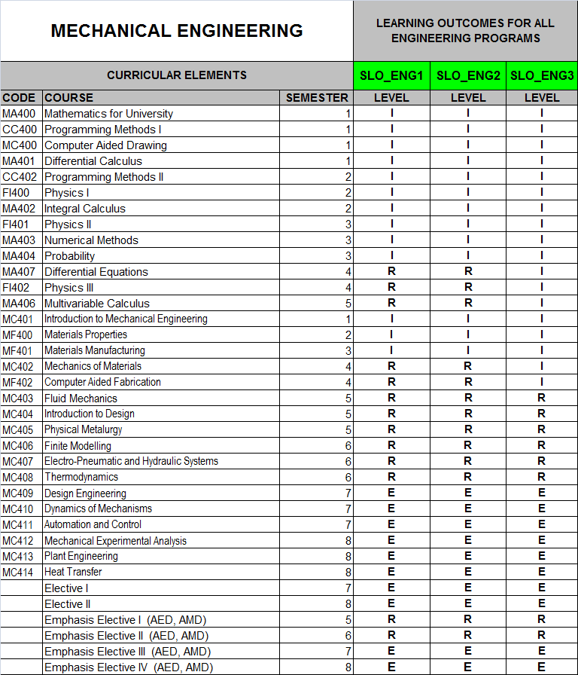

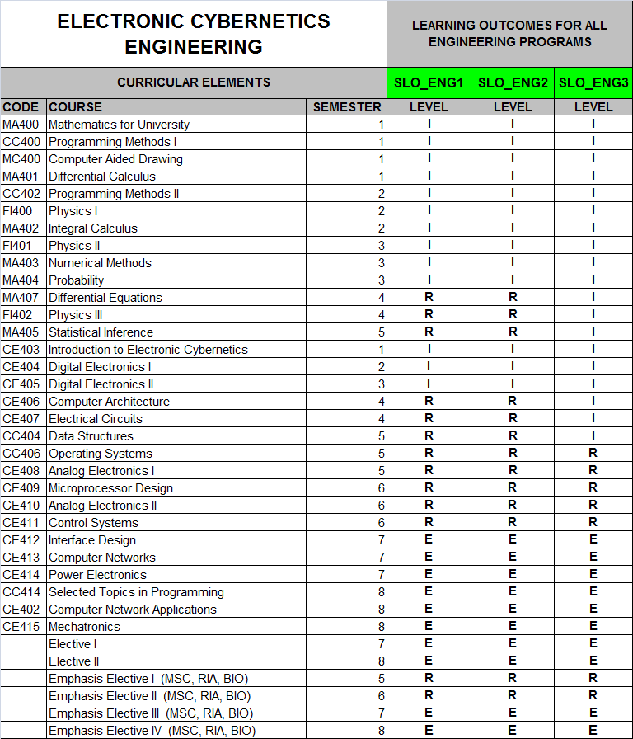 | 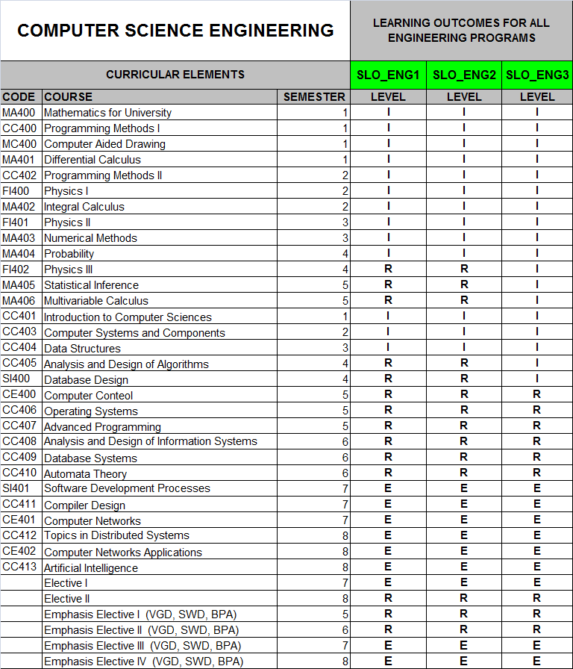

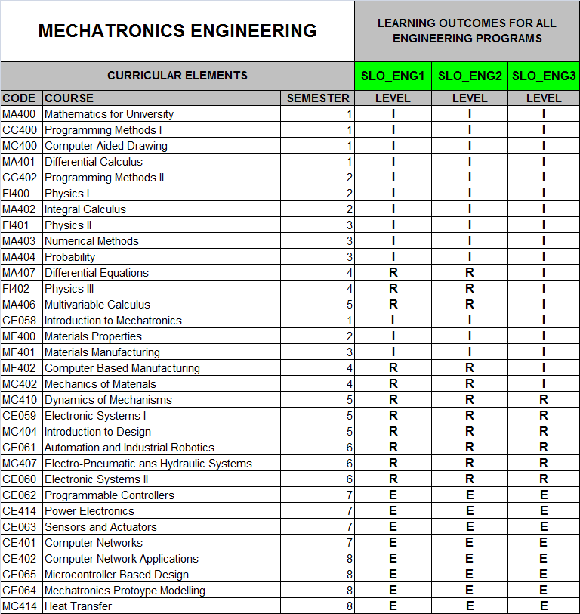 | 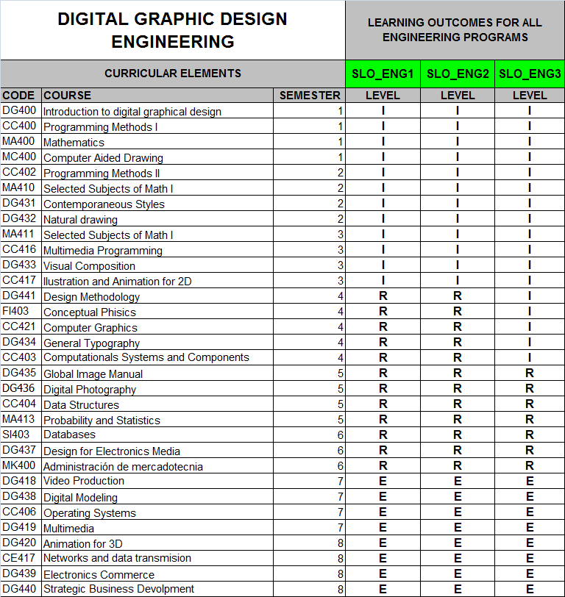

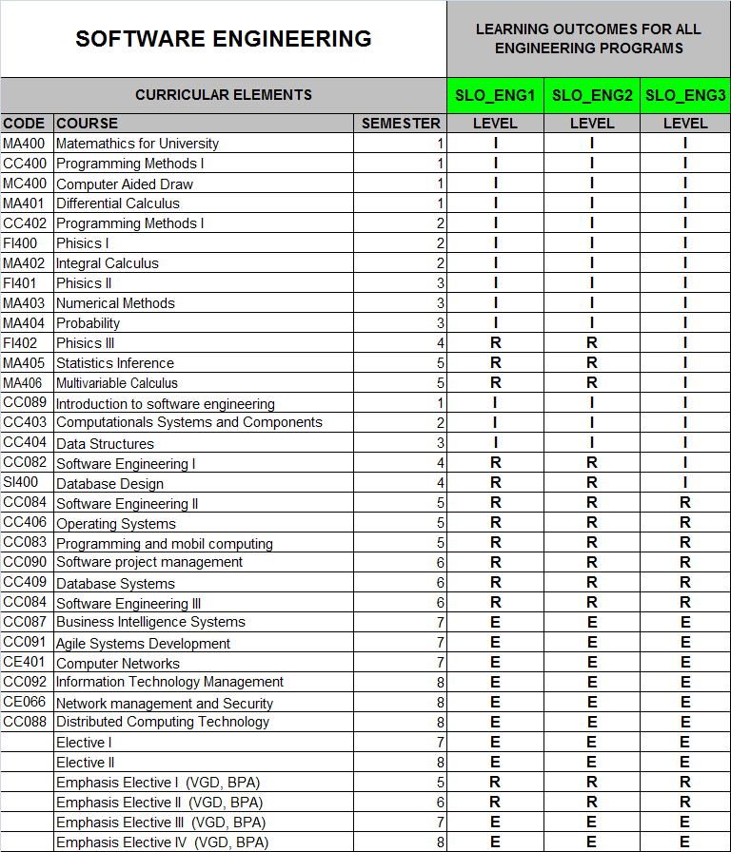 | It is important to note that, for all academic programs, in the case of SLO_ENG3 (“Clear and effective communication in English”), there are curricular elements such as the Advanced Communications in English course (5th semester), and also program level courses offered in English beginning in 5th semester. The development of clear and effective communication in English is developed primarily via the co-curricular ESL program that all students must go through, and which is managed by the English Language Center.

3. Assessment Plan for August-December 2010.

At the program level, the College of Engineering decided to designate an Assessment Officer to design a pilot assessment plan and program for the August-December 2010 semester for all Engineering Programs offered by the College. The responsible for this process was M.S. Jorge Sosa López, with the collaboration of the Deans of the Schools of Engineering and Chairs of each Academy.

This pilot project is divided in two stages, the first to be deployed during the second semester of 2010 focuses on program level learning outcomes common to all engineering program. The second stage focuses on program level outcomes specific to the academic program, as well as external assessment data relating to the EGEL exit examination administered by CENEVAL.

This assessment plan has the goal to not only define a structure and methodology for assessment at the program level for the College of Engineering, that can be integrated as seamlessly as possible to the academic dynamic of the courses offered by the College of Engineering, but also with a strong faculty participation in the design of the assessment plan and process, providing a case study that not only integrates what has been achieved by the institutional process, but builds upon it.

The process and methodology that was defined consists of 6 key components:

- Selection of Learning Outcomes: Each Academy, based upon the set of Program Level Learning Outcomes (common and specific) defined for the academic programs, will select at least one learning outcome to assess during each assessment cycle.

- Course selection for assessment: Based upon the curriculum, and curricular mapping, each Academy, with the aid of the Deans of the Schools of Engineering, will define in which courses the assessment process will be implemented. It is important that the selected courses span the length of the academic program.

- Design of Instruments for Assessment: Each Academy will design or select instruments to assess the selected learning outcomes. Examples of these may be various types of rubrics. Participation of various faculty members is not only encouraged, but strongly recommended.

- Definition of learning activities and evidence of learning: Once learning outcomes, and courses are defined, learning activities and their corresponding evidence of learning are identified and defined. The congruency between this and the instruments defined in 3) is important. Both 3) and 4) may be done concurrently.

- Training of faculty: With the aid of the Deans of the Schools of Engineering, faculty who will participate in assessment during the cycle are provided training regarding terminology, methodology as well as the instruments to be used. Close collaboration with faculty is key to the success of the process.

- Assessment during semester: The learning outcomes are assessed in the selected courses, using the defined instruments for the learning activities and corresponding learning evidence. This part of the process is supervised by the Deans of the Schools of Engineering in each Campus.

- Analysis of results: At the end of the cycle, results are presented to the Academies and analyzed to identify areas of opportunity to be included as a part of the program review process.

Assessment Plan for the August-December 2010 semester.

- Selection of Learning Outcomes: The Academies decided that, for this first assessment cycle, all programs would assess the first two Program Level Learning Outcomes that are common to all Engineering Programs, meaning SLO_ENG1 and SLO_ENG2.

The student of a CETYS University Bachelor’s in Engineering Program will…
- SLO_ENG1: …solve problems relating to the improvement of diverse systems, correctly applying the knowledge and tools provided by the basic sciences and/or software technologies.
- SLO_ENG2: … effectively design and manage projects.

- Course selection for assessment: Based upon the course offering for the August-December 2010 semester, courses were selected for assessment. Since institutional learning outcomes assessment was also being done during the same semester, courses were selected with an effort to have compatibility and congruency with the institutional level assessment process, and also so as to not overburden faculty members.

The complete set of courses offered by the College of Engineering during the August-December 2010 semester is listed in the next page (including the curricular mapping for SLO_ENG1 and SLO_ENG2), in which each course has a color that identifies it as “belonging” to one of the 6 academies of the College of Engineering:

- Academy of Industrial Engineering. This Academy is responsible for the Industrial Engineering Program (offered in the three Campuses). The chair of this Academy is M.S. Socorro Lomelí (Ensenada Campus).

- Academy of Computer Science and Software. This Academy is responsible for the Computer Science Engineering Program (offered in the Mexicali and Tijuana Campuses), and the Software Engineering Program (offered in the Ensenada Campus). The chair of this Academy is M.S. Guillermo Cheang (Mexicali Campus).

- Academy of Cybernetics and Mechatronics. This Academy is responsible for the Electronic Cybernetics Engineering Program and Mechatronics Engineering Programs (both are offered in the three Campuses). The chair of this Academy is M.S. Cristóbal Capiz (Mexicali Campus).

- Academy of Mechanical Engineering. This Academy is responsible for the Mechanical Engineering Program (offered in the three Campuses). The chair of this Academy is M.S. Bernardo Valadez (Mexicali Campus).

- Academy of Digital Graphic Design Engineering. This Academy is responsible for the Digital Graphic Design Engineering Program (offered in the three Campuses). The chair of this Academy is M.S. Fabian Bautista (Tijuana Campus).

- Academy de Basic Sciences. This is the only Academy that is not responsible for an academic program, but is responsible in overseeing the Basic Sciences courses offered in all the Engineering academic programs. This Academy works with all the other Academies and is chaired by M.S. Salvador Baltazar (Mexicali Campus).
Courses offered by the College of Engineering – August-December 2010
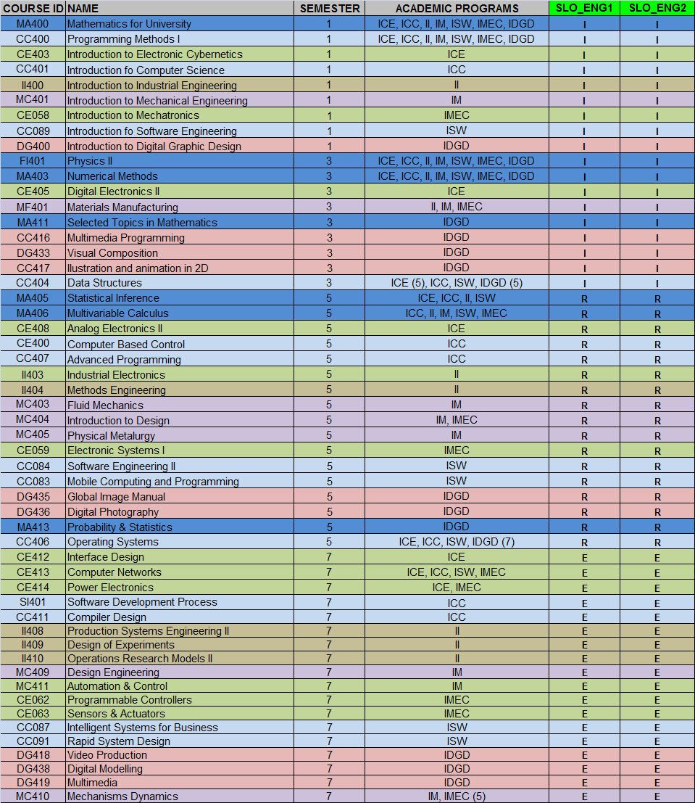

The academic programs are:
- II = Industrial Engineering
- IM = Mechanical Engineering
- ICC = Computer Science Engineering
- ICE = Electronic Cybernetics Engineering
- IMEC = Mechatronics Engineering
- ISW = Software Engineering
- IDGD = Digital Graphic Design Engineering

The levels used for the curricular mapping of SLO_ENG1 and SLO_ENG 2 are INTRODUCTORY (I), REINFORCEMENT (R) and EVALUATION (E), explained in section 2 of this document.
From the complete course listing for the August-December 2010 semester, a subset of courses was selected for assessment, following the criteria that these courses should span all academic programs, as well as all semesters. The following list shows the subset of 16 selected courses:

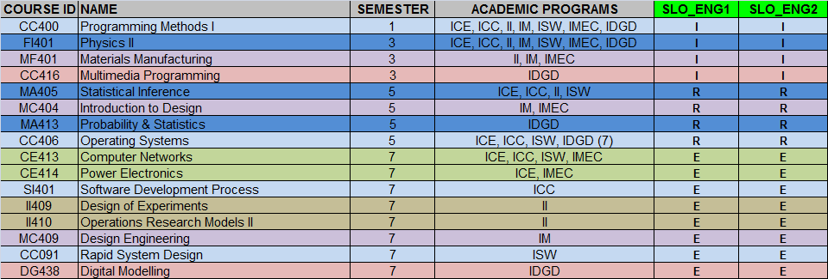

- Design of Instruments for Assessment: Each Academy made proposals for instruments to be used to assess SLO_ENG1 and SLO_ENG2, and these were analyzed and integrated, resulting in the definition of two rubrics, a holistic one for SLO_ENG1 and an analytical one for SLO_ENG2. Each rubric document begins with a cover page with the following information:

The holistic rubric designed to assess SLO_ENG1 was the following:

The analytic rubric designed to assess SLO_ENG2 was the following:
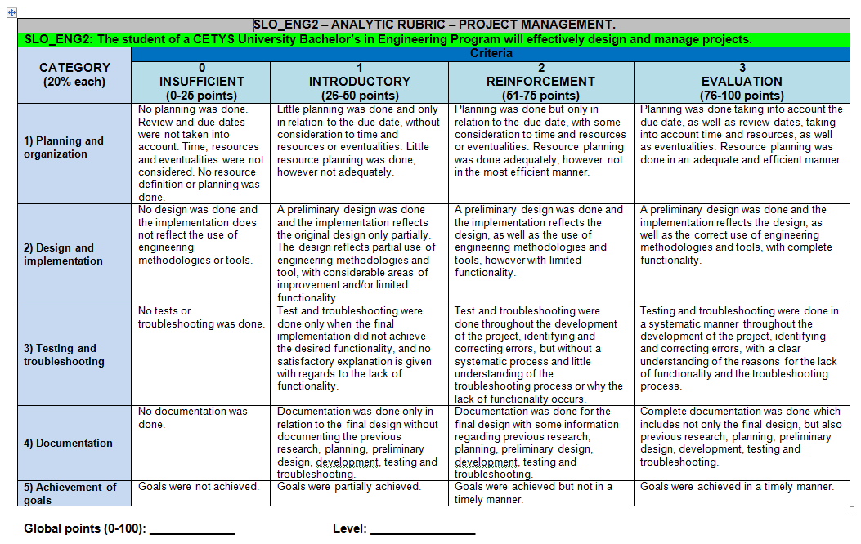
- Definition of learning activities and evidence of learning: The 16 courses were divided between each Academy, according to areas of knowledge, and each Academy worked with their faculty members to identify learning activities and evidence of learning that could be used for the assessment of SLO_ENG1 and SLO_ENG2, considering the normal coursework that faculty do during a regular semester in which the courses are offered, and also in congruency with the instruments defined in 3) Each academy delivered a learning activity and evidence of learning description document. Following the same mentality described in 2), activities were selected in which both SLO_ENG1 and SLO_ENG2 could be assessed (and if possible, also institutional learning outcomes). It is not surprising that most activities follow a project and/or problem based learning scheme.

The following table shows a brief description of the learning activities defined by each academy for the selected courses:

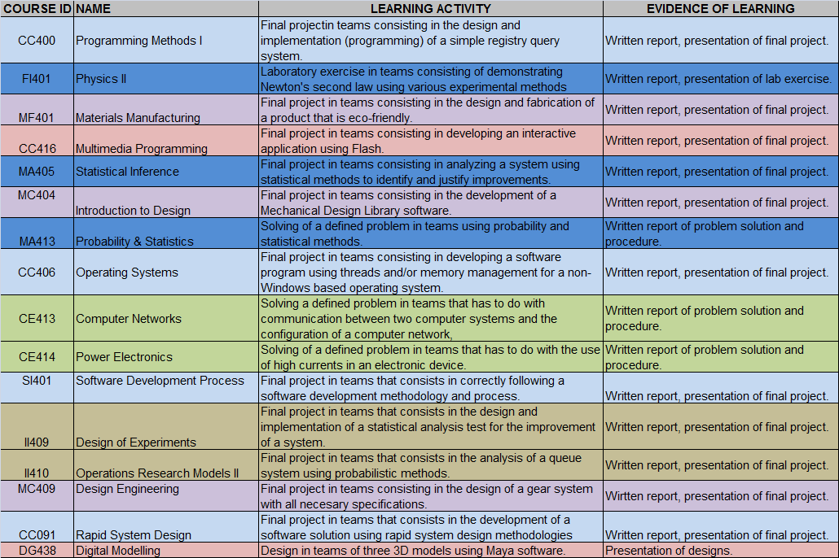

Additional support documentation for faculty was developed by the academies for each of the proposed learning activities. This documentation explains in further detail the characteristics of the learning activity and evidence of learning.

- Training of faculty: With the aid of the Deans of the Schools of Engineering, each Campus trained the group of faculty who would teach the selected courses during the August-December 2010 semester, and therefore would participate in assessment during the cycle.

- Assessment during semester: The assessment cycle was deployed during the August-December 2010 semester and results, including evidence of learning, were gathered by each School Director for each Campus.

- Analysis of results: The results were analyzed by each Academy during the first semester of 2011. (The results are integrated into the corresponding Program Review document).

For following assessment cycles, it is expected that an assessment scheme that allows for assessment of institutional and both program level types of learning outcomes be designed, however, the bulk of workload that this would imply needs to be analyzed with detail.

4. Assessment Plan for January-June 2011.

The second stage of the assessment plan focuses on program level outcomes specific to the academic program.

Each Academy first defines the program level specific learning outcomes to be assessed, and then goes through the following stages:

- Definition of rubrics.
Faculty from each campus define a proposal of the type and format for the rubrics to be applied during the semester. These proposals are analyzed by the Academy as a group and validated for use.

- Definition of period for assessment.
At the beginning of each semester, the Academy will define which rubrics will be applied during the semester.

- Identification of courses where assessment will be applied.
Based upon the curricular mapping for the academic program, courses are selected for assessment.

- Notification to faculty involved in assessment activities.
Faculty is notified and trained in the use of the rubric if necessary.

- Definition of learning activities and evidence.
Faculty select learning activities and evidence for assessment, according to the selected course and curricular mapping.

- Students upload their work to the electronic portfolio during the semester.
Students do the assigned learning activity and upload their work to the electronic portfolio.

- Faculty evaluate and provide feedback to students.
Faculty evaluate student work using the previously designed rubrics and provide feedback to the students, as well as a general summary of assessment results.

- Faculty generate a summary of assessment results.
Each faculty member generates a summary of assessment results for student learning based upon the selected course and rubric.
- The Academy analyzes the summary of assessment results.
The Academy analyzes assessment results as a group, identifying areas of opportunity and improvement. If expected learning is not achieved, then an action plan is defined. The analysis of assessment results seeks to answer the question: what does this data mean with regards to student learning?

NOTE: The results are integrated into the corresponding Program Review document.

ASSESSMENT DATA FROM EXTERNAL SOURCES.

It is necessary to identify additional objective metrics to include in the design and deployment of assessment plans and programs. Currently, last-year students present an undergraduate exit examination (EGEL) administered by CENEVAL (an organization in México that offers various examination services), and designed by academics from different universities all over Mexico.

CENEVAL (National Center for Evaluation of Higher Education) in México has developed a series of instruments to evaluate basic knowledge for professionals that have concluded their academic programs. The instrument is called EGEL (Undergraduate Exit Examination) and has specific versions designed for various academic programs, using a scale that measures professional requirements established by industry and government, for new professionals.

In CETYS, graduating undergraduate students do the EGEL examination in their last semester of studies, and the results obtained are an external indicator that provides important information for program review, and specifically learning outcomes and educational objectives analysis, as well as modifications to the curriculum.

Since 2006, systematic information regarding the EGEL examination is available for analysis, and up until 2009, the EGEL examination evaluated areas specific to the academic program with a focus on knowledge evaluation.

The global CENEVAL index was evaluated using three levels of achievement: ANS (Unsatisfactory Achievement), DS (Satisfactory Achievement) and DSS (Outstanding Achievement).

In the year 2010, the EGEL examination was modified to evaluate knowledge and abilities for professionals, with a competencies based focus.

Each Academy analyzed the results of the EGEL examination for their academic program, as an external source for assessment information.

NOTE: The results are integrated into the corresponding Program Review document.

